VOLUME 3
CLOUD ROBOTICS
Cloud Robotics | Cloud Infrastructure | Connected Robot Applications
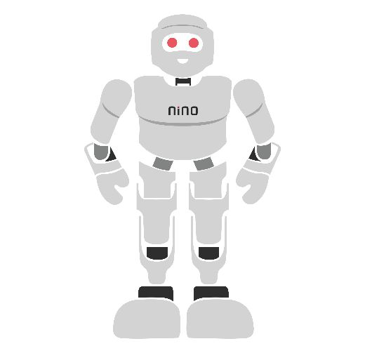

Module Overview
A single robot has a small computer, a limited battery and only its own experience. Connected to the internet, it can use almost unlimited computing power, store and share huge maps and data sets, learn from thousands of other robots, receive software updates and be watched over by people anywhere in the world. Connecting robots to remote computing resources in this way is called cloud robotics. It powers warehouse fleets, delivery robots, inspection drones and service robots — but it also brings new problems: network delay, lost connections, cost and security.
This module explains when and how to use the cloud with robots. Section 1 covers the ideas, benefits and limits of cloud robotics and how to decide what should run on the robot and what in the cloud. Section 2 explains the cloud infrastructure — computing, storage, networking, containers and the MQTT messaging protocol. Section 3 shows complete connected robot applications: telemetry, fleet management, remote operation, cloud AI, software updates and security, including how to connect ROS 2 robots. The labs build a working connected fleet with a real MQTT broker, a cloud REST service and an automatic fleet supervisor; all outputs shown were produced by running the code. Taught end-to-end, the module is designed to fill approximately 28–32 hours of instruction and practice.
# | Topic | Hands-on Focus
1 | Introduction to Cloud Robotics | Decide what runs on the robot, edge or cloud
2 | Cloud Infrastructure | Lab 1: MQTT telemetry and monitoring
3 | Connected Robot Applications | Lab 2: Latency and offloading · Lab 3: Fleet REST service
4 | Practical Lab Exercises (with model solutions) | Python, Mosquitto, Flask, Docker
5 | Integrated Mini-Project: Cloud Fleet Supervisor | Automatic docking and failure detection
6–7 | Troubleshooting, Assessment and Revision | Formula sheet, questions, rubric

Learning Outcomes
By the end of this module, learners will be able to:
- Explain cloud robotics, its benefits and its limitations, and give real examples.
- Decide which robot functions should run on the robot, at the edge or in the cloud, using latency and bandwidth calculations.
- Describe cloud service models, regions, virtual machines, containers, storage options and networking basics.
- Use MQTT topics, quality-of-service levels, retained messages and last-will messages to connect robots to the cloud.
- Build a cloud service with a REST API that monitors a fleet and sends commands, and package it as a container.
- Design connected applications — telemetry, fleet rules, teleoperation, cloud AI and over-the-air updates — that stay safe when the network fails.
- Apply basic security and privacy measures to connected robots.
Hardware and Software Required
Item | Purpose | Notes
PC or laptop (Linux, Windows or macOS) | Run the broker, cloud service and simulated robots | Ubuntu used in examples
Python 3.10+ with paho-mqtt, Flask, requests, NumPy, Matplotlib | Lab programs | pip install paho-mqtt flask requests numpy matplotlib
Mosquitto MQTT broker and clients | Message broker for all labs | sudo apt install mosquitto mosquitto-clients
Docker and Docker Compose (optional) | Package and deploy the cloud service | Free for education
Optional: free-tier cloud account (any provider) | Deploy the service on a real cloud server | Watch usage limits and costs
Optional: ROS 2 robot or simulation (ROS 2 module) | Connect a real ROS 2 robot with the bridge node | Not required for the labs

1. Introduction to Cloud Robotics

1.1 What Is Cloud Robotics?
Cloud robotics means robots that use computing, storage and services located elsewhere — in remote data centres (the cloud) or in nearby servers (the edge) — through a network. The term was popularised by James Kuffner at Google in 2010. The robot keeps its body, sensors and fast reflexes, while the cloud acts as a shared "brain extension" and memory (Figure 1.1). Early research projects such as RoboEarth (a European "World Wide Web for robots", 2009–2014) showed that robots could download maps, object models and task descriptions created by other robots.
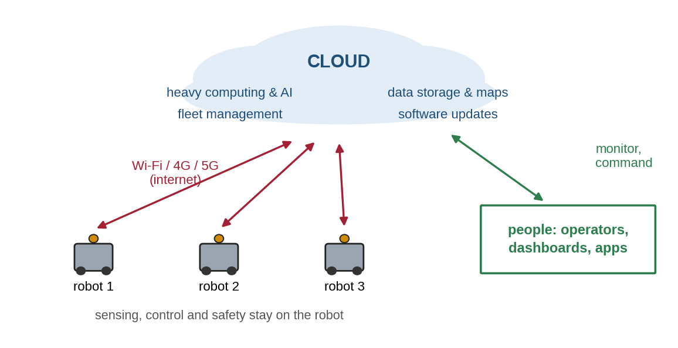
Figure 1.1: Cloud robotics: robots keep sensing and control on board and use the cloud for heavy computing, shared data, fleet management and updates.

1.2 Benefits
- Computing power: run large AI models, 3D mapping or planning on cloud GPUs instead of a small robot computer — making robots cheaper, lighter and longer-lasting on battery.
- Shared knowledge: maps, object models and learned skills gathered by one robot can be used by all others.
- Fleet management: watch and control hundreds of robots from one dashboard; assign tasks; detect problems early.
- Data and learning: store sensor logs for analysis, testing and training better AI models.
- Updates and maintenance: send new software to every robot over the air; diagnose faults remotely.

1.3 Challenges
- Latency: every trip to the cloud and back takes time — tens to hundreds of milliseconds, sometimes more.
- Bandwidth: cameras and lidars produce far more data than mobile networks can upload.
- Connectivity: Wi-Fi drops in lifts and basements; mobile signal is weak in remote sites. The robot must stay safe offline.
- Security and privacy: a connected robot can be attacked remotely, and its cameras may capture people.
- Cost and dependence: cloud services cost money every month, and providers can change or retire services.

1.4 Where Should Each Function Run?
The key design decision is computation placement (Figure 1.2). Anything that must react within milliseconds or is needed for safety — motor control, emergency stop, obstacle avoidance — must run on the robot. Heavy work that can wait a little — map building, AI training, fleet dashboards — fits the cloud. Edge servers on the same site (in the factory or warehouse) sit in between: much faster than the cloud and still powerful.
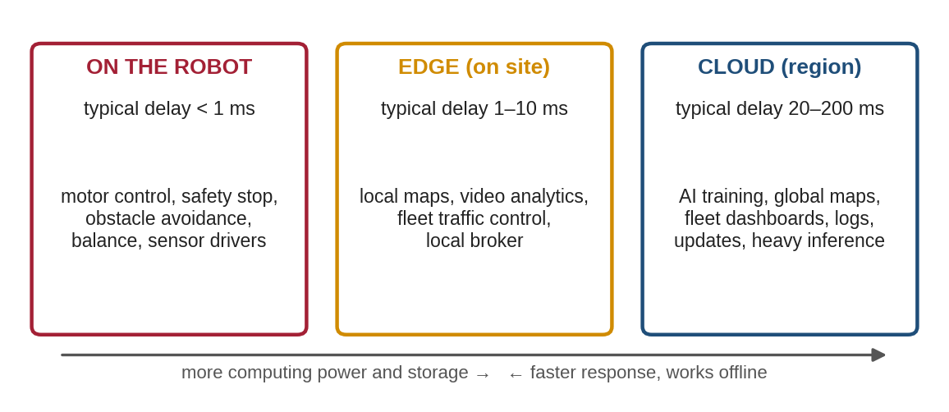
Figure 1.2: The robot–edge–cloud continuum: typical delays and the functions that belong at each level.
A function is worth offloading to the cloud only if the cloud response time is shorter than doing it locally (or the result is much better), and the function can tolerate the delay and occasional failure:
T_cloud = T_capture + D ÷ B_up + RTT + T_compute,cloud + T_act < T_local (1.1)
where D is the data size, B_up the upload bandwidth and RTT the network round-trip time. Worked example 1.1 (Figure 1.3). A robot must detect objects in a 200 kB camera image. On its own CPU this takes 450 ms; on a cloud GPU 25 ms. With a 10 Mbit/s uplink, uploading takes 200 × 8 ÷ 10,000 s = 160 ms; with RTT = 40 ms, capture 15 ms and acting 10 ms, the total is about 250 ms — offloading wins. On a weak 2 Mbit/s 4G link, the upload alone takes 800 ms and local processing is better. Upload bandwidth, not cloud speed, usually decides (Lab 2).
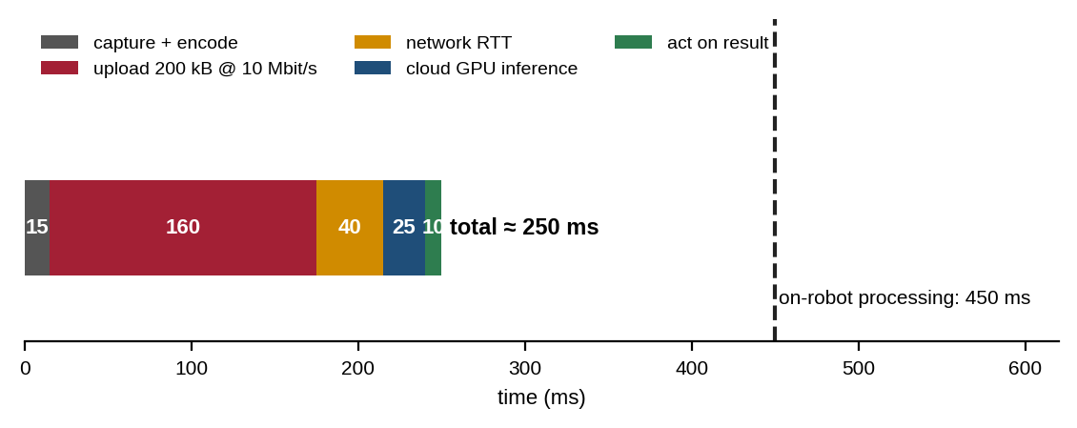
Figure 1.3: Latency budget for offloading one image to a cloud GPU over a 10 Mbit/s uplink.

1.5 The Physics of Delay
Even a perfect network cannot beat the speed of light. Light in optical fibre travels at about 200,000 km/s. Worked example 1.2. A data centre 1,500 km away gives a minimum round trip of 2 × 1,500 ÷ 200,000 = 0.015 s = 15 ms, before any routing, queuing, wireless access or processing time — real values are often 2–5 times higher. A balance or motor control loop running at 100 Hz has only 10 ms per cycle, which is why such loops can never run in a distant cloud. Choosing a nearby cloud region or an edge server reduces delay.

1.6 Cloud Robotics in Practice
Example | What the cloud does
Warehouse robot fleets | Assigns orders and routes to hundreds of robots, monitors batteries and faults
Large-scale grasp learning (Google research) | Collected data from 14 robot arms to train one shared grasping network
Delivery and service robots | Remote monitoring and help from human operators when the robot is stuck
Inspection robots and drones | Uploads images and measurements for analysis and reports
Cloud robotics platforms (e.g. Rapyuta, from RoboEarth) | Provide fleet tools, simulation and deployment as services

1.7 Common Mistakes to Avoid
- Putting safety or fast control loops in the cloud.
- Assuming the network is always available — design for disconnection from the start.
- Sending raw camera streams when only the detection result is needed.

2. Cloud Infrastructure

2.1 What Is Cloud Computing?
Cloud computing is renting computing resources over the internet instead of owning them. The widely used NIST definition lists five characteristics: on-demand self-service (create a server in minutes), broad network access, resource pooling (many customers share large data centres), rapid elasticity (scale up and down with demand) and measured service (pay for what you use). Large providers operate data centres in many regions around the world; each region contains several isolated availability zones, so that one failure does not stop a service.

2.2 Service and Deployment Models
Cloud services differ in how much the provider manages for you (Figure 2.1). With IaaS (Infrastructure as a Service) you rent virtual machines and manage the operating system and software yourself. With PaaS (Platform as a Service) you only supply your application and data. With SaaS (Software as a Service) you simply use a finished application, such as a fleet dashboard. Clouds can be public (shared, run by a provider), private (run by one organisation, often on its own site) or hybrid (both together).
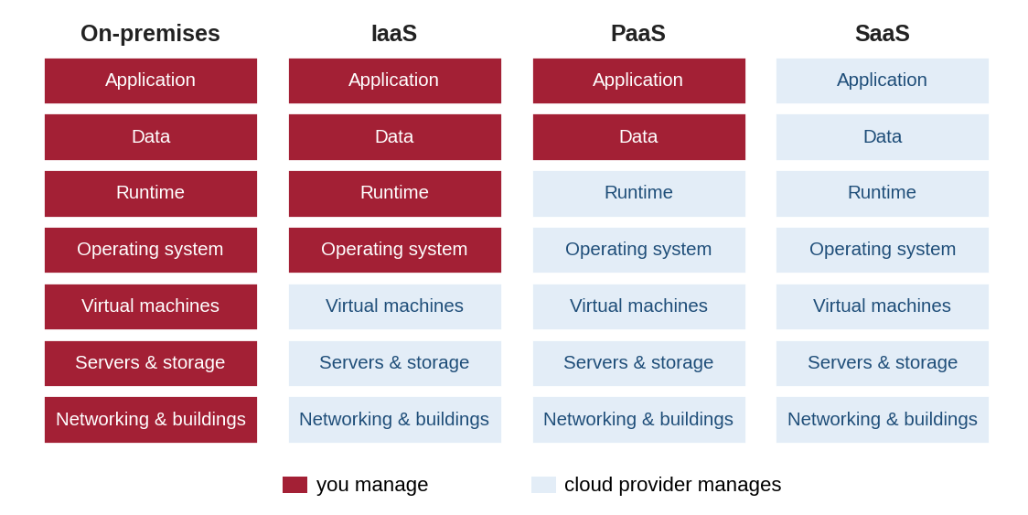
Figure 2.1: Who manages what in on-premises, IaaS, PaaS and SaaS models.

2.3 Compute: Virtual Machines, Containers and Serverless
A virtual machine (VM) is a complete simulated computer with its own operating system. A container packages only an application with its libraries and shares the host’s operating system kernel (Figure 2.2), so it starts in seconds and runs identically on a laptop, a cloud server or even the robot. Docker is the most common container tool; Kubernetes manages many containers across many servers, restarting failed ones and scaling them with demand. Serverless functions run small pieces of code only when an event arrives, and you pay per call.
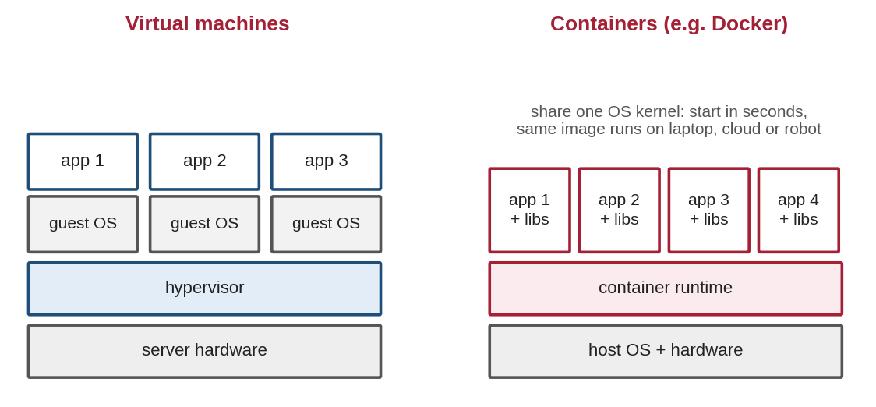
Figure 2.2: Virtual machines each include a full operating system; containers share one host operating system.

2.4 Storage and Databases
Type | Good for | Robot example
Object storage | Large files, cheap, very durable | Sensor logs (rosbags), images, maps, software images
Block storage | Disks attached to a virtual machine | Database files of a fleet server
Relational database (SQL) | Structured records with relations | Robots, users, tasks, maintenance history
Time-series database | Many timestamped measurements | Battery, position, temperature telemetry
Key-value / document store | Fast lookup of the latest state | Current status of each robot

2.5 Networking Basics
Robots reach the cloud through Wi-Fi, 4G/5G mobile networks or wired Ethernet. Each server has an IP address, and services listen on ports (e.g. 443 for HTTPS, 1883 for MQTT, 8883 for MQTT over TLS). DNS turns names such as fleet.example.com into addresses. Firewalls allow only the needed ports. Robots are usually behind routers that block incoming connections, so the robot should open the connection outwards to the cloud (as MQTT does) rather than wait for the cloud to call in. A VPN creates an encrypted private network across the internet. TLS encrypts traffic and proves the server’s identity with a certificate.

2.6 Messaging Protocols for Robots
Protocol | Pattern | Strengths | Typical use
MQTT | Publish/subscribe via a broker | Very light, works on poor networks, QoS levels | Telemetry and commands
HTTP / REST | Request/response | Universal, easy to test, works with web apps | APIs for dashboards and services
WebSocket | Two-way stream over HTTP | Live browser connections | rosbridge, live web dashboards
gRPC | Remote procedure calls | Fast, typed, streaming | Service-to-service calls
DDS (ROS 2) | Publish/subscribe, peer-to-peer | Rich QoS; designed for local networks | Inside the robot or site, not across the internet
Zenoh | Pub/sub + queries | Designed for robot-to-edge-to-cloud | ROS 2 over wide-area networks

2.7 MQTT in Detail
MQTT is an open OASIS standard (versions 3.1.1 and 5.0) built for devices on unreliable networks. Clients never talk to each other directly; they publish messages to named topics on a broker and subscribe to topics they care about (Figure 2.3). Topics form a hierarchy such as fleet/robot1/telemetry; the wildcard + matches one level (fleet/+/telemetry = every robot) and # matches everything below a level.
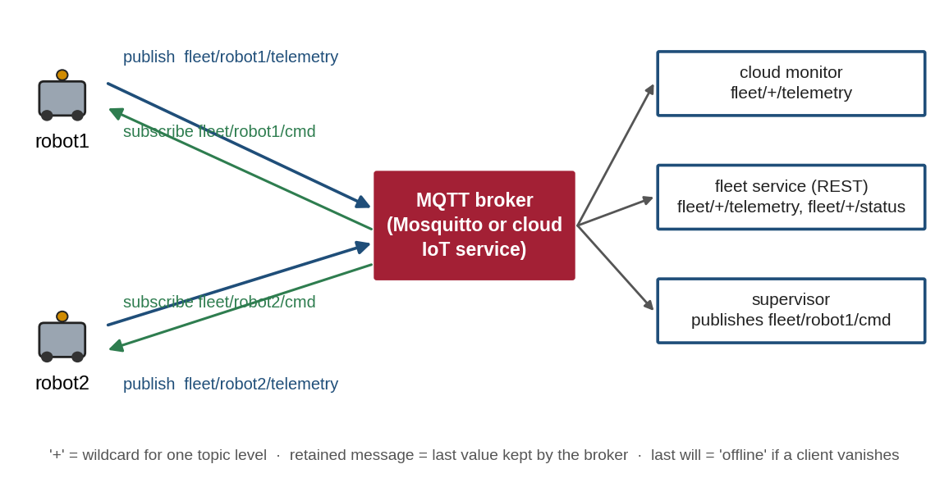
Figure 2.3: MQTT publish/subscribe for a robot fleet: robots and cloud services only talk to the broker.
- QoS 0 (at most once), QoS 1 (at least once, may duplicate) and QoS 2 (exactly once) trade speed against delivery guarantees. Telemetry usually uses 0 or 1; commands use 1 with duplicate-safe handling.
- A retained message is stored by the broker and delivered immediately to every new subscriber — ideal for "current status".
- A last will and testament (LWT) is registered at connection; if the client vanishes without disconnecting properly, the broker publishes it for the client (e.g. offline).
- Keep-alive: the client sends a small ping if it has nothing else to send; if the broker hears nothing for 1.5 × the keep-alive time, it treats the client as gone. With a 5 s keep-alive the theoretical limit is 7.5 s; in a test for this module, a frozen robot was declared offline by Mosquitto about 9–10 s after it stopped. Fleet services therefore often add their own faster heartbeat watchdog.

2.8 Managed IoT Platforms and Lock-in
Major cloud providers offer managed IoT services that run MQTT brokers at large scale with device identities, rules engines and dashboards. They save work but can tie you to one provider, and services can be withdrawn: for example, Google retired its Cloud IoT Core service in August 2023, forcing users to migrate. Using open protocols (MQTT, HTTP), containers and clear interfaces keeps a robot system portable.

2.9 Estimating Data and Cost
Worked example 2.1. A 300-byte JSON telemetry message sent once per second produces 300 × 86,400 = 25.9 MB per robot per day. A fleet of 50 robots therefore sends about 1.3 GB per day, or 39 GB per month; at 10 messages per second it would be about 390 GB per month. Multiply volumes by the provider’s prices for messages, storage and outgoing data, and add server running time (e.g. hours per month × hourly price). Simple choices — sending summaries instead of raw data, lower rates, compression and deleting old logs — often cut costs several times.

2.10 Common Mistakes to Avoid
- Leaving brokers or databases open to the internet without passwords or TLS.
- Using DDS discovery directly across the internet instead of a bridge or VPN.
- Choosing a far-away region and then blaming the robot for slow responses.
- Ignoring data-transfer and storage costs until the first monthly bill.

3. Connected Robot Applications

3.1 A Reference Architecture
Figure 3.1 shows a typical architecture for a connected robot fleet. On each robot, ROS 2 nodes do sensing, navigation and control, and an independent local safety layer stops the robot whatever the network does. A small bridge sends selected data to the cloud and receives high-level commands. In the cloud, a broker receives messages, services store data and apply fleet logic, AI services and an update server provide extra capabilities, and people use dashboards or apps through HTTPS.
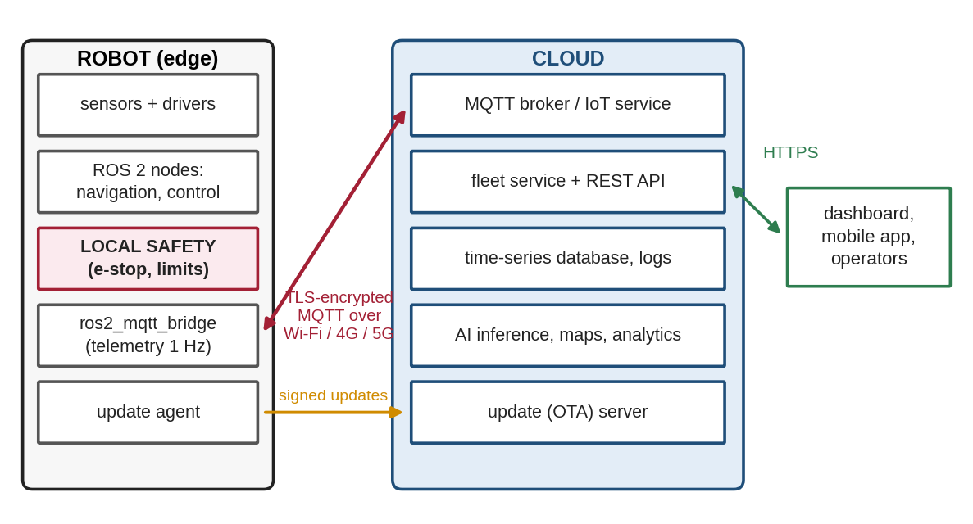
Figure 3.1: Reference architecture of a connected robot fleet with on-robot safety and cloud services.

3.2 Telemetry and Remote Monitoring
Telemetry is the regular stream of status data from robot to cloud: battery, position, mode, errors, temperatures. Send what people and fleet logic need, at the rate they need it — usually 0.2–1 Hz for dashboards, not the 30–100 Hz used inside the robot. Use small, versioned JSON messages with a robot ID and timestamp, send events (errors, task done) immediately, and keep a retained "online/offline" status with a last-will message. Dashboards then show the fleet on a map, highlight alarms and plot history.

3.3 Fleet Management
A fleet management service turns telemetry into decisions: assigning tasks to the best robot, sending robots to charge, detecting robots that stopped reporting (heartbeat watchdog), coordinating traffic in narrow corridors and scheduling maintenance. Rules can be simple ("battery below 25 % → dock") or use optimisation. Commands from the cloud must be high-level ("go to dock", "pause", "start task 17") — the robot itself plans and executes them safely. The mini-project builds such a supervisor.

3.4 Remote Operation (Teleoperation)
When a robot is stuck or a task is unusual, a human can help remotely. Direct joystick driving over the internet suffers from delay: the operator sees an old picture and over-corrects, and performance drops noticeably as delays grow towards a few hundred milliseconds. Practical systems therefore use supervised autonomy: the operator clicks a goal or approves a plan, and the robot moves by itself with its local safety layer active. Always limit speed during remote operation and stop automatically if the connection is lost.

3.5 Cloud AI and Shared Knowledge
Cloud GPUs can run large perception, speech and language models that do not fit on the robot, provided the offloading rule (1.1) is met and the robot has a fallback when the cloud does not answer. Fleets also learn together: data from many robots trains better models, and shared maps and object libraries let a new robot work in a building it has never seen. Results returned by cloud AI must be checked on the robot before they are acted upon.

3.6 Data Logging and Digital Twins
Robots record their sensor data (for ROS 2, with ros2 bag) and upload it — usually only around interesting events and over Wi-Fi while charging — for debugging, testing and training. A digital twin is a live virtual copy of a robot or site in the cloud, kept up to date with telemetry; engineers use it to monitor, test changes in simulation and predict maintenance before touching the real system.

3.7 Over-the-Air (OTA) Updates
Updating hundreds of robots by hand is impossible, so software is delivered over the air (Figure 3.2). A safe process builds a versioned (often containerised) release, tests it, signs it cryptographically so robots accept only genuine software, installs it first on a small canary group, watches error rates and then rolls it out in waves — with an automatic rollback to the previous version if problems appear. Robots should update only when idle or charging.
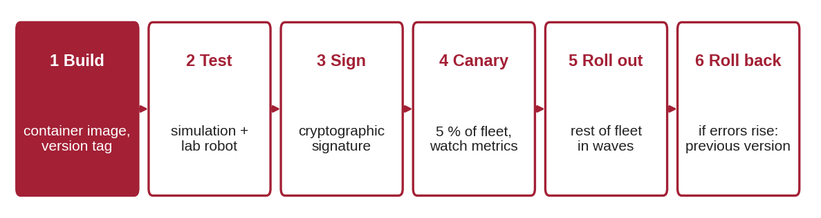
Figure 3.2: A safe over-the-air update process with canary release and rollback.

3.8 Connecting ROS 2 Robots to the Cloud
ROS 2’s DDS communication is designed for local networks: its automatic discovery uses multicast and many ports, which do not cross the internet well and should not be exposed to it. Common ways to connect ROS 2 robots to the cloud are: (1) a bridge node that forwards selected topics to MQTT (below); (2) rosbridge, which offers ROS topics and services as JSON over WebSocket for web dashboards; (3) Zenoh, a protocol designed for robot-to-cloud communication, with a ROS 2 middleware implementation (rmw_zenoh); or (4) a VPN that puts robot and server on one private network. The bridge below sends battery and position once per second and turns a cloud stop command into a zero-velocity message, while all real motion control stays local:
# ros2_mqtt_bridge.py - run ON THE ROBOT: forward ROS 2 data to the cloud and cloud commands to ROS 2
import json
import rclpy
from rclpy.node import Node
from nav_msgs.msg import Odometry
from sensor_msgs.msg import BatteryState
from geometry_msgs.msg import Twist
import paho.mqtt.client as mqtt

class Ros2MqttBridge(Node):
def __init__(self):
super().__init__('ros2_mqtt_bridge')
self.declare_parameter('robot_id', 'robot1')
self.declare_parameter('broker', 'localhost')
self.rid = self.get_parameter('robot_id').value
self.state = {'battery': None, 'x': None, 'y': None}
self.create_subscription(Odometry, '/odom', self.on_odom, 10)
self.create_subscription(BatteryState, '/battery_state', self.on_battery, 10)
self.cmd_pub = self.create_publisher(Twist, '/cmd_vel', 10)
self.mq = mqtt.Client(mqtt.CallbackAPIVersion.VERSION2, client_id=self.rid)
self.mq.will_set(f'fleet/{self.rid}/status', 'offline', qos=1, retain=True)
self.mq.on_message = self.on_cloud_cmd
self.mq.connect(self.get_parameter('broker').value, 1883, keepalive=10)
self.mq.subscribe(f'fleet/{self.rid}/cmd', qos=1)
self.mq.publish(f'fleet/{self.rid}/status', 'online', qos=1, retain=True)
self.mq.loop_start()
self.create_timer(1.0, self.send_telemetry) # 1 Hz to the cloud, not 30 Hz

def on_odom(self, msg):
self.state['x'] = round(msg.pose.pose.position.x, 2)
self.state['y'] = round(msg.pose.pose.position.y, 2)

def on_battery(self, msg):
self.state['battery'] = round(100.0 * msg.percentage, 1) # ROS uses 0..1

def send_telemetry(self):
self.mq.publish(f'fleet/{self.rid}/telemetry', json.dumps({'id': self.rid, **self.state}), qos=1)

def on_cloud_cmd(self, client, userdata, msg):
cmd = json.loads(msg.payload)
self.get_logger().info(f'cloud command: {cmd}')
if cmd.get('action') == 'stop':
self.cmd_pub.publish(Twist()) # zero velocity; safety stays local
# 'dock' would start a local navigation goal (e.g. Nav2) - never raw motor control from the cloud

def main():
rclpy.init()
node = Ros2MqttBridge()
try:
rclpy.spin(node)
except KeyboardInterrupt:
pass
node.mq.loop_stop()
node.destroy_node()
rclpy.try_shutdown()

if __name__ == '__main__':
main()

3.9 Security and Privacy
A connected robot is a computer with motors and cameras on the internet, so security failures can cause physical harm. Use defence in depth — several independent layers (Figure 3.3) — so that one mistake does not expose everything. Give every robot its own credentials, encrypt all traffic with TLS, open no inbound ports on robots, apply updates, log access and collect only the personal data you need. Relevant references include the IEC 62443 series for industrial automation security, ISO/IEC 27001 for information-security management and data-protection laws such as India’s Digital Personal Data Protection Act 2023 and the EU GDPR.
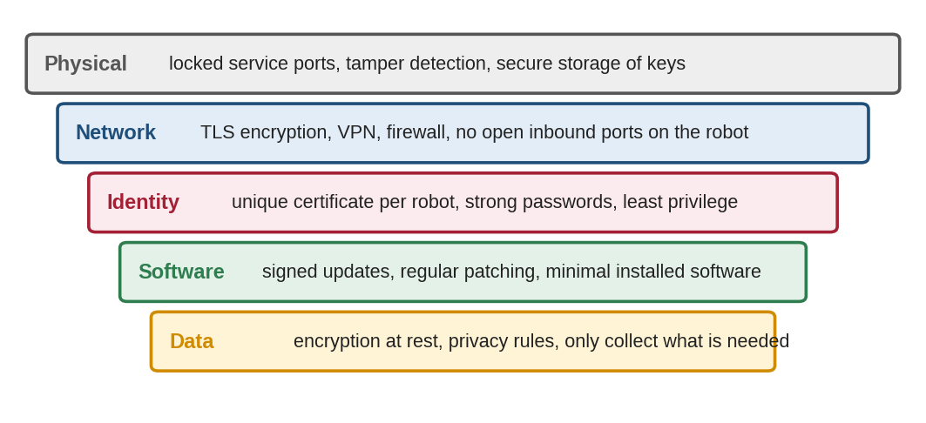
Figure 3.3: Defence in depth for a connected robot: physical, network, identity, software and data protection layers.

3.10 Common Mistakes to Avoid
- Letting the cloud send raw velocity commands without local checks.
- Robots that stop working entirely when the internet drops, instead of continuing or stopping safely.
- Shared passwords for the whole fleet — one stolen robot exposes every robot.
- Updating all robots at once with no canary group and no rollback.

4. Practical Lab Exercises
The labs build a small connected fleet step by step on one computer: simulated robots, an MQTT broker standing in for the cloud broker, a monitoring client, a cloud REST service and an automatic supervisor. Moving to a real cloud only changes the broker address and adds TLS and passwords. All outputs below were produced by running the programs with Mosquitto 2.0 and paho-mqtt 2.1; timing values will differ slightly on your computer.
Setup (once)
sudo apt install mosquitto mosquitto-clients # broker + command-line tools (Ubuntu)
pip install paho-mqtt flask requests numpy matplotlib # Python libraries
mosquitto -v # start a broker in a terminal (port 1883, local only)

On Windows or macOS, install Mosquitto from mosquitto.org. If you cannot run a broker, the public test broker test.mosquitto.org works for experiments — but anyone can read its messages, so never send real data there and use a unique topic prefix.
Shared robot simulator (used by every lab). Each robot publishes telemetry every second, obeys dock, stop and resume commands, registers a last-will offline status and can simulate a power cut with --crash-at:
# robot_sim.py - a simulated connected robot: publishes telemetry, obeys cloud commands (MQTT)
import argparse, json, math, os, time
import paho.mqtt.client as mqtt

p = argparse.ArgumentParser()
p.add_argument("--id", default="robot1")
p.add_argument("--host", default="localhost")
p.add_argument("--battery", type=float, default=100.0) # start charge (%)
p.add_argument("--drain", type=float, default=0.5) # % per second while patrolling
p.add_argument("--period", type=float, default=1.0) # seconds between telemetry messages
p.add_argument("--duration", type=float, default=30.0)
p.add_argument("--crash-at", type=float, default=None) # simulate a power cut at this time (s)
a = p.parse_args()
state = {"battery": a.battery, "x": 2.0, "y": 0.0, "mode": "patrol"}

def on_message(client, userdata, msg):
cmd = json.loads(msg.payload)
action = cmd.get("action")
if action == "dock" and state["mode"] == "patrol":
state["mode"] = "docking"
elif action == "stop":
state["mode"] = "stopped"
elif action == "resume":
state["mode"] = "patrol"
print(f"[{a.id}] command received: {cmd} -> mode {state['mode']}", flush=True)

client = mqtt.Client(mqtt.CallbackAPIVersion.VERSION2, client_id=a.id)
client.will_set(f"fleet/{a.id}/status", "offline", qos=1, retain=True) # sent by the broker if we vanish
client.on_message = on_message
client.connect(a.host, 1883, keepalive=5)
client.subscribe(f"fleet/{a.id}/cmd", qos=1)
client.publish(f"fleet/{a.id}/status", "online", qos=1, retain=True)
client.loop_start() # network traffic runs in a background thread

t0 = time.time()
while (t := time.time() - t0) < a.duration:
if a.crash_at is not None and t >= a.crash_at:
os._exit(1) # no clean disconnect -> broker sends the last will
m = state["mode"]
if m == "patrol":
state["x"], state["y"] = 2*math.cos(0.2*t), 2*math.sin(0.2*t)
state["battery"] = max(0.0, state["battery"] - a.drain*a.period)
elif m == "docking": # drive towards the charger at (0, 0)
state["x"] *= 0.5; state["y"] *= 0.5
state["battery"] = max(0.0, state["battery"] - 0.5*a.drain*a.period)
if math.hypot(state["x"], state["y"]) < 0.2:
state["mode"] = "charging"
elif m == "charging":
state["battery"] = min(100.0, state["battery"] + 8.0*a.period)
if state["battery"] >= 100.0:
state["mode"] = "patrol"
msg = {"id": a.id, "t": round(t, 1), "battery": round(state["battery"], 1),
"x": round(state["x"], 2), "y": round(state["y"], 2), "mode": state["mode"]}
client.publish(f"fleet/{a.id}/telemetry", json.dumps(msg), qos=1)
time.sleep(a.period)

client.publish(f"fleet/{a.id}/status", "offline", qos=1, retain=True).wait_for_publish()
client.loop_stop()
client.disconnect()

Lab Exercise 1: MQTT Telemetry and Cloud Monitoring
Estimated time | Prerequisites
2.5 hours | Sections 2.6–2.7; Python basics

Objective
To publish robot telemetry to an MQTT broker, monitor a fleet with wildcard subscriptions, send commands by hand and observe retained and last-will messages.
Working Principle
Robots publish JSON to fleet/<id>/telemetry and a retained status to fleet/<id>/status. The monitor subscribes to fleet/+/telemetry and fleet/+/status, so new robots appear automatically. If a robot disappears without disconnecting, the broker publishes its last will (offline).
Procedure
- Start the broker. In terminal 2 run python3 cloud_monitor.py --duration 10.
- Within one second start two robots: python3 robot_sim.py --id robot1 --battery 26 --drain 1.5 --duration 7 and python3 robot_sim.py --id robot2 --battery 80 --drain 0.5 --duration 20 --crash-at 4.
- Record the output. Note when robot1’s alert starts and when robot2 goes offline.
- Watch raw traffic with mosquitto_sub -v -t 'fleet/#', start a robot and send a command by hand: mosquitto_pub -t fleet/robot5/cmd -q 1 -m '{"action": "stop"}' (use the robot’s ID).
- After all robots have stopped, run mosquitto_sub -v -t 'fleet/+/status'. Explain what you see.
Program Code
# cloud_monitor.py - Lab 1: subscribe to all robots' telemetry and status, raise simple alerts
import argparse, json, time
import paho.mqtt.client as mqtt

p = argparse.ArgumentParser()
p.add_argument("--host", default="localhost")
p.add_argument("--duration", type=float, default=12.0)
a = p.parse_args()

def on_connect(client, userdata, flags, reason_code, properties):
print(f"connected to broker: {reason_code}")
client.subscribe([("fleet/+/telemetry", 1), ("fleet/+/status", 1)]) # '+' = any robot id

def on_message(client, userdata, msg):
robot = msg.topic.split("/")[1]
if msg.topic.endswith("/status"):
print(f"STATUS {robot}: {msg.payload.decode()}")
return
d = json.loads(msg.payload)
line = f"TELEM {robot}: t={d['t']:5.1f}s battery={d['battery']:5.1f}% pos=({d['x']:5.2f},{d['y']:5.2f}) {d['mode']}"
if d["battery"] < 20:
line += " <-- ALERT: low battery"
print(line)

client = mqtt.Client(mqtt.CallbackAPIVersion.VERSION2, client_id="cloud_monitor")
client.on_connect, client.on_message = on_connect, on_message
client.connect(a.host, 1883, keepalive=30)
client.loop_start()
time.sleep(a.duration)
client.loop_stop()
client.disconnect()

Expected Output
connected to broker: Success
STATUS robot2: online
TELEM robot2: t= 0.0s battery= 79.5% pos=( 2.00, 0.00) patrol
STATUS robot1: online
TELEM robot1: t= 0.0s battery= 24.5% pos=( 2.00, 0.00) patrol
TELEM robot2: t= 1.0s battery= 79.0% pos=( 1.96, 0.40) patrol
TELEM robot1: t= 1.0s battery= 23.0% pos=( 1.96, 0.40) patrol
TELEM robot2: t= 2.0s battery= 78.5% pos=( 1.84, 0.78) patrol
TELEM robot1: t= 2.0s battery= 21.5% pos=( 1.84, 0.78) patrol
TELEM robot2: t= 3.0s battery= 78.0% pos=( 1.65, 1.13) patrol
TELEM robot1: t= 3.0s battery= 20.0% pos=( 1.65, 1.13) patrol
STATUS robot2: offline
TELEM robot1: t= 4.0s battery= 18.5% pos=( 1.39, 1.44) patrol <-- ALERT: low battery
TELEM robot1: t= 5.0s battery= 17.0% pos=( 1.08, 1.68) patrol <-- ALERT: low battery
TELEM robot1: t= 6.0s battery= 15.5% pos=( 0.72, 1.86) patrol <-- ALERT: low battery
STATUS robot1: offline

Observation
# | What to observe | Your observation
1 | Time of robot1’s first low-battery alert
2 | Time between robot2’s crash and its offline status
3 | Effect of the manual stop command on telemetry
4 | Output of the late status subscription and why

Model Solution
# | Correct result | Explanation
1 | t = 4.0 s (battery 18.5 %) | 26 % − 1.5 % per second drops below 20 % after the 4th message
2 | Less than 1 s | The crash closed the socket, so the broker noticed at once and sent the last will (a cut cable would take about 1.5 × keep-alive)
3 | Robot prints "command received … mode stopped"; mode becomes stopped and battery stops falling (e.g. 48.0 % twice) | Commands use QoS 1 on the robot’s own cmd topic
4 | fleet/robot1/status offline, fleet/robot2/status offline, … immediately | Status messages are retained: new subscribers get the last value at once

Conclusion
MQTT topics, wildcards, retained messages and last wills give a complete, light fleet-monitoring channel in a few lines of code. Evidence: terminal outputs and completed tables.

Lab Exercise 2: Latency Measurement and Offloading Decisions
Estimated time | Prerequisites
2.5 hours | Sections 1.4–1.5; Lab 1

Objective
To measure message round-trip time through a broker and to calculate when sending camera images to a cloud GPU is faster than processing them on the robot.
Working Principle
Part A sends 200 timestamped ping messages; an echo client returns each as pong, and the program records round-trip times. Part B applies equation (1.1) without the capture and acting terms (the same on both sides): cloud time = RTT + upload time + cloud compute. The break-even uplink makes cloud and local times equal. The model values (450 ms local, 25 ms cloud GPU, 200 kB image) are example assumptions to be replaced with your own measurements.
Procedure
- Run the program with the local broker and record Part A and Part B results.
- Repeat Part A with the public broker (HOST = "test.mosquitto.org", change the topics to a unique prefix). Compare the RTT values.
- Use your measured internet RTT in Part B. Does the decision for good 4G change?
- A newer robot processes the image locally in 120 ms. Find the new break-even uplink.
- Explain why a 100 Hz motor-control loop can never be offloaded.
Program Code
# Lab 2: measure MQTT round-trip time, then decide when offloading to the cloud pays off
import json, statistics, threading, time
import numpy as np
import matplotlib.pyplot as plt
import paho.mqtt.client as mqtt

HOST, N = "localhost", 200

# ---- Part A: ping-pong round-trip time through the broker
echo = mqtt.Client(mqtt.CallbackAPIVersion.VERSION2, client_id="echo")
echo.on_message = lambda c, u, m: c.publish("lab/pong", m.payload, qos=0)
echo.connect(HOST, 1883); echo.subscribe("lab/ping"); echo.loop_start()

rtts, got = [], threading.Event()
def on_pong(c, u, m):
rtts.append((time.perf_counter() - json.loads(m.payload)["t"]) * 1000.0) # ms
got.set()
pinger = mqtt.Client(mqtt.CallbackAPIVersion.VERSION2, client_id="pinger")
pinger.on_message = on_pong
pinger.connect(HOST, 1883); pinger.subscribe("lab/pong"); pinger.loop_start()
time.sleep(0.5)
for i in range(N):
got.clear()
pinger.publish("lab/ping", json.dumps({"i": i, "t": time.perf_counter()}), qos=0)
got.wait(1.0)
time.sleep(0.005)
for c in (echo, pinger):
c.loop_stop(); c.disconnect()
r = np.array(rtts)
print(f"Round trips: {len(r)}/{N} mean {r.mean():.2f} ms median {np.median(r):.2f} ms "
f"95th percentile {np.percentile(r, 95):.2f} ms max {r.max():.2f} ms")

# ---- Part B: offloading model for one camera image (assumed example values - edit them)
LOCAL_MS = 450.0 # detection on the robot's small CPU
CLOUD_MS = 25.0 # same detection on a cloud GPU
IMAGE_KB = 200.0 # compressed camera image
RTT_MS = 40.0 # network round trip to the cloud region

def cloud_total(uplink_mbps, rtt_ms=RTT_MS):
upload_ms = IMAGE_KB * 8 / 1000 / uplink_mbps * 1000 # kB -> Mbit -> seconds -> ms
return rtt_ms + upload_ms + CLOUD_MS

for name, up in [("Wi-Fi / fibre", 50), ("good 4G", 10), ("weak 4G", 2)]:
t = cloud_total(up)
print(f"{name:13s} uplink {up:3d} Mbit/s: cloud {t:6.1f} ms vs local {LOCAL_MS:.0f} ms -> "
f"{'OFFLOAD' if t < LOCAL_MS else 'KEEP LOCAL'}")
up_break = IMAGE_KB * 8 / (LOCAL_MS - RTT_MS - CLOUD_MS) # Mbit/s where both are equal
print(f"Break-even uplink: {up_break:.2f} Mbit/s")

bw = np.linspace(1, 50, 200)
plt.figure(figsize=(6.5, 3.2))
for rtt in (20, 40, 100):
plt.plot(bw, [cloud_total(b, rtt) for b in bw], label=f"cloud, RTT {rtt} ms")
plt.axhline(LOCAL_MS, color="k", ls="--", label="on-robot processing")
plt.ylim(0, 1000); plt.xlabel("uplink bandwidth (Mbit/s)"); plt.ylabel("response time (ms)")
plt.grid(alpha=0.3); plt.legend(fontsize=8); plt.tight_layout(); plt.savefig("lab2_output.png", dpi=150); plt.show()

Expected Output
Round trips: 200/200 mean 0.32 ms median 0.27 ms 95th percentile 0.51 ms max 3.31 ms
Wi-Fi / fibre uplink 50 Mbit/s: cloud 97.0 ms vs local 450 ms -> OFFLOAD
good 4G uplink 10 Mbit/s: cloud 225.0 ms vs local 450 ms -> OFFLOAD
weak 4G uplink 2 Mbit/s: cloud 865.0 ms vs local 450 ms -> KEEP LOCAL
Break-even uplink: 4.16 Mbit/s

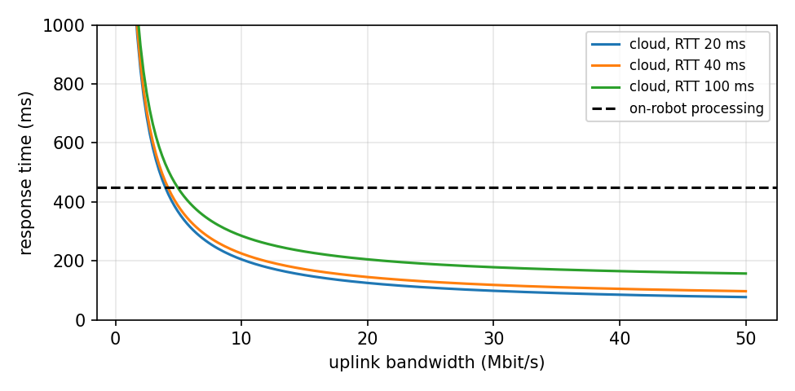
Figure 4.1: Output of Lab 2: cloud response time against uplink bandwidth for three network round-trip times, compared with on-robot processing.
Observation
# | What to observe | Your observation
1 | Local broker RTT (median, 95th percentile)
2 | Internet broker RTT (median, 95th percentile)
3 | Decision for good 4G with your RTT
4 | Break-even uplink for 120 ms local processing
5 | Why a 100 Hz control loop cannot be offloaded

Model Solution
# | Correct result | Explanation
1 | ≈ 0.3 ms median, ≈ 0.5 ms 95th percentile | Same computer: no real network
2 | Typically tens to hundreds of ms, with large spikes | Distance, routing and shared servers; use the 95th percentile, not the mean, for design
3 | Usually still OFFLOAD unless RTT > 265 ms | 450 − 160 − 25 = 265 ms of RTT is allowed
4 | 200 × 8 ÷ (120 − 40 − 25) = 29.1 Mbit/s | A faster robot makes offloading worthwhile only on fast links
5 | 10 ms per cycle is less than any internet RTT | Plus the loop would stop whenever the network drops — unsafe

Conclusion
Offloading decisions must be calculated, not guessed; upload bandwidth and worst-case delay usually decide. Evidence: outputs, plot and calculations.

Lab Exercise 3: Cloud Fleet Service with a REST API
Estimated time | Prerequisites
3 hours | Sections 2.3, 2.6 and 3.3; Labs 1–2

Objective
To build a cloud service that collects fleet telemetry over MQTT, exposes it through a REST API, accepts validated commands, and is packaged as a container.
Working Principle
A background MQTT client stores the latest status and telemetry of each robot in memory (protected by a lock because two threads use it). Flask provides three endpoints: GET /robots, GET /robots/<id> and POST /robots/<id>/cmd. Commands are validated before being published to the robot’s cmd topic; the service answers 202 Accepted because the robot acts on them asynchronously. The broker address comes from the environment variable MQTT_HOST, so the same code runs locally and in Docker.
Procedure
- Start the broker, then python3 fleet_service.py.
- Start two robots: --id robot1 --battery 60 --drain 1 --duration 12 and --id robot2 --battery 90 --drain 0.5 --duration 12.
- After about 2 s run python3 lab3_test_client.py and record every response and HTTP status code.
- Open http://localhost:8000/robots in a browser while robots are running.
- If Docker is available, run docker compose up --build, start robots against localhost, and repeat step 3.
Program Code
# fleet_service.py - Lab 3: cloud fleet service = MQTT ingestion + REST API (Flask)
import json, os, threading, time
from flask import Flask, jsonify, request, abort
import paho.mqtt.client as mqtt

BROKER = os.environ.get("MQTT_HOST", "localhost") # set by Docker Compose in deployment
fleet, lock = {}, threading.Lock() # latest data per robot (in memory)

def on_connect(client, userdata, flags, reason_code, properties):
client.subscribe([("fleet/+/telemetry", 1), ("fleet/+/status", 1)])

def on_message(client, userdata, msg):
robot = msg.topic.split("/")[1]
with lock:
entry = fleet.setdefault(robot, {"status": "unknown", "telemetry": None, "last_seen": None})
if msg.topic.endswith("/status"):
entry["status"] = msg.payload.decode()
else:
entry["telemetry"] = json.loads(msg.payload)
entry["last_seen"] = time.time()

mq = mqtt.Client(mqtt.CallbackAPIVersion.VERSION2, client_id="fleet_service")
mq.on_connect, mq.on_message = on_connect, on_message
mq.connect(BROKER, 1883, keepalive=30)
mq.loop_start()

app = Flask(__name__)

@app.get("/robots")
def list_robots():
with lock:
return jsonify({rid: {"status": e["status"],
"battery": e["telemetry"]["battery"] if e["telemetry"] else None,
"mode": e["telemetry"]["mode"] if e["telemetry"] else None}
for rid, e in fleet.items()})

@app.get("/robots/<rid>")
def robot_detail(rid):
with lock:
if rid not in fleet:
abort(404)
e = dict(fleet[rid])
e["seconds_since_seen"] = round(time.time() - e["last_seen"], 1) if e["last_seen"] else None
return jsonify(e)

@app.post("/robots/<rid>/cmd")
def send_command(rid):
cmd = request.get_json(force=True)
if cmd.get("action") not in ("dock", "stop", "resume"):
return jsonify({"error": "action must be dock, stop or resume"}), 400
mq.publish(f"fleet/{rid}/cmd", json.dumps(cmd), qos=1)
return jsonify({"sent": cmd, "to": rid}), 202

if __name__ == "__main__":
app.run(host="0.0.0.0", port=8000)

# lab3_test_client.py - call the fleet service REST API like a dashboard or another service would
import json, time
import requests

BASE = "http://localhost:8000"
def show(title, r):
print(f"{title} [HTTP {r.status_code}]")
print(" ", json.dumps(r.json()))

show("GET /robots", requests.get(f"{BASE}/robots"))
show("GET /robots/robot1", requests.get(f"{BASE}/robots/robot1"))
show("POST /robots/robot1/cmd {action: dock}", requests.post(f"{BASE}/robots/robot1/cmd", json={"action": "dock"}))
show("POST /robots/robot1/cmd {action: fly}", requests.post(f"{BASE}/robots/robot1/cmd", json={"action": "fly"}))
time.sleep(2.5)
show("GET /robots (2.5 s later)", requests.get(f"{BASE}/robots"))
print(f"GET /robots/robot9 [HTTP {requests.get(f'{BASE}/robots/robot9').status_code}]")

Container files (Dockerfile, docker-compose.yml and a development-only mosquitto.conf):
# Dockerfile - package the fleet service as a container image
FROM python:3.12-slim
WORKDIR /app
RUN pip install --no-cache-dir flask paho-mqtt
COPY fleet_service.py .
EXPOSE 8000
CMD ["python", "fleet_service.py"]

# docker-compose.yml - run the MQTT broker and the fleet service together
services:
broker:
image: eclipse-mosquitto:2
ports: ["1883:1883"]
volumes: ["./mosquitto.conf:/mosquitto/config/mosquitto.conf:ro"]
fleet-service:
build: .
environment: { MQTT_HOST: broker }
ports: ["8000:8000"]
depends_on: [broker]
restart: unless-stopped

# mosquitto.conf - development only: accept anonymous clients on port 1883 (use TLS + passwords in production)
listener 1883
allow_anonymous true

Expected Output
GET /robots [HTTP 200]
{"robot1": {"battery": 57.0, "mode": "patrol", "status": "online"}, "robot2": {"battery": 88.5, "mode": "patrol", "status": "online"}}
GET /robots/robot1 [HTTP 200]
{"last_seen": 1791870692.9228747, "seconds_since_seen": 0.5, "status": "online", "telemetry": {"battery": 57.0, "id": "robot1", "mode": "patrol", "t": 2.0, "x": 1.84, "y": 0.78}}
POST /robots/robot1/cmd {action: dock} [HTTP 202]
{"sent": {"action": "dock"}, "to": "robot1"}
POST /robots/robot1/cmd {action: fly} [HTTP 400]
{"error": "action must be dock, stop or resume"}
GET /robots (2.5 s later) [HTTP 200]
{"robot1": {"battery": 56.0, "mode": "docking", "status": "online"}, "robot2": {"battery": 87.5, "mode": "patrol", "status": "online"}}
GET /robots/robot9 [HTTP 404]
--- robot1 terminal:
[robot1] command received: {'action': 'dock'} -> mode docking

The last_seen value is a Unix timestamp and will differ on every run. The Docker files were checked for valid syntax but were not run for this module.
Observation
# | What to observe | Your observation
1 | Response and status code of each request
2 | Mode of robot1 before and after the dock command
3 | Why the service answers 202 instead of 200 for commands
4 | Result of the Docker deployment (if available)

Model Solution
# | Correct result | Explanation
1 | 200, 200, 202, 400, 200, 404 (as in the expected output) | 400 = invalid action rejected; 404 = unknown robot
2 | patrol → docking (battery now falling at half rate) | The command travelled HTTP → service → MQTT → robot
3 | The command was accepted, not yet completed | The robot executes it later; its new mode appears in telemetry
4 | Same responses at http://localhost:8000 | MQTT_HOST=broker lets the service find the broker container by name

Conclusion
A cloud service turns many robot message streams into one simple, validated API for dashboards and other services, and containers make it portable to any cloud. Evidence: outputs, browser screenshot and (optionally) Docker logs.

5. Integrated Mini-Project: Cloud Fleet Supervisor

5.1 Problem Statement
A building operator runs three patrol robots. Build a cloud fleet supervisor that, without human help, (1) sends any working robot with a battery below 25 % to its charger, (2) reports when it has docked and when it is fully charged, (3) reports robots that disconnect, and (4) warns when a robot stops sending telemetry while still connected (for example, frozen software). It must also log all telemetry and plot it.

5.2 Design
Rule | Trigger | Action
Low battery | battery < 25 % and mode = patrol | Publish {action: dock} once; log event
Docked / charged | mode = charging, then patrol again | Log events
Disconnected | status topic changes to offline (last will) | Log alarm
Heartbeat watchdog | No telemetry for 3 s while status = online | Log warning (faster than broker keep-alive)

# fleet_supervisor.py - mini-project: automatic fleet rules in the cloud + data log + plot
import argparse, csv, json, time
import paho.mqtt.client as mqtt

p = argparse.ArgumentParser()
p.add_argument("--host", default="localhost")
p.add_argument("--duration", type=float, default=50.0)
p.add_argument("--dock-below", type=float, default=25.0) # % battery that triggers docking
p.add_argument("--stale-after", type=float, default=3.0) # s without telemetry = connection problem
a = p.parse_args()

t0 = time.time()
fleet, log, events = {}, [], []

def event(text):
line = f"[{time.time() - t0:5.1f} s] {text}"
events.append(line); print(line, flush=True)

def on_connect(client, userdata, flags, reason_code, properties):
client.subscribe([("fleet/+/telemetry", 1), ("fleet/+/status", 1)])

def on_message(client, userdata, msg):
robot = msg.topic.split("/")[1]
r = fleet.setdefault(robot, {"last": time.time(), "docking_sent": False, "status": "?", "stale": False})
if msg.topic.endswith("/status"):
status = msg.payload.decode()
if status != r["status"]:
event(f"{robot} is {status.upper()}")
r["status"] = status
return
d = json.loads(msg.payload)
r["last"], r["stale"] = time.time(), False
log.append((round(time.time() - t0, 1), robot, d["battery"], d["mode"]))
# Rule 1: low battery while working -> send the robot to its charger (once)
if d["battery"] < a.dock_below and d["mode"] == "patrol" and not r["docking_sent"]:
client.publish(f"fleet/{robot}/cmd", json.dumps({"action": "dock"}), qos=1)
r["docking_sent"] = True
event(f"{robot} battery {d['battery']}% -> DOCK command sent")
if d["mode"] == "charging" and r["docking_sent"]:
event(f"{robot} reached the charger and is charging")
r["docking_sent"] = None # do not repeat this message
if d["mode"] == "patrol" and r["docking_sent"] is None:
event(f"{robot} fully charged, back on patrol")
r["docking_sent"] = False

client = mqtt.Client(mqtt.CallbackAPIVersion.VERSION2, client_id="fleet_supervisor")
client.on_connect, client.on_message = on_connect, on_message
client.connect(a.host, 1883, keepalive=30)
client.loop_start()
while time.time() - t0 < a.duration:
# Rule 2: heartbeat watchdog - no telemetry for a while although not reported offline
for robot, r in list(fleet.items()):
if r["status"] == "online" and not r["stale"] and time.time() - r["last"] > a.stale_after:
r["stale"] = True
event(f"{robot} WARNING: no telemetry for {a.stale_after:.0f} s")
time.sleep(0.2)
client.loop_stop(); client.disconnect()

with open("fleet_log.csv", "w", newline="") as f:
csv.writer(f).writerows([("t", "robot", "battery", "mode")] + log)
print(f"saved {len(log)} telemetry rows to fleet_log.csv")

5.3 Running the Scenario
python3 fleet_supervisor.py --duration 48 &
python3 robot_sim.py --id robot1 --battery 40 --drain 1.5 --duration 45 &
python3 robot_sim.py --id robot2 --battery 60 --drain 1.0 --duration 45 &
python3 robot_sim.py --id robot3 --battery 80 --drain 0.5 --duration 45 --crash-at 25 &
wait; python3 plot_fleet.py # reads fleet_log.csv and saves mini_output.png

[ 0.0 s] robot2 is OFFLINE
[ 0.0 s] robot1 is OFFLINE
[ 1.1 s] robot1 is ONLINE
[ 1.1 s] robot2 is ONLINE
[ 1.1 s] robot3 is ONLINE
[ 11.1 s] robot1 battery 23.5% -> DOCK command sent
[ 15.2 s] robot1 reached the charger and is charging
[ 25.2 s] robot1 fully charged, back on patrol
[ 26.2 s] robot3 is OFFLINE
[ 36.2 s] robot2 battery 24.0% -> DOCK command sent
[ 40.2 s] robot2 reached the charger and is charging
[ 46.2 s] robot2 is OFFLINE
[ 46.2 s] robot1 is OFFLINE
saved 115 telemetry rows to fleet_log.csv

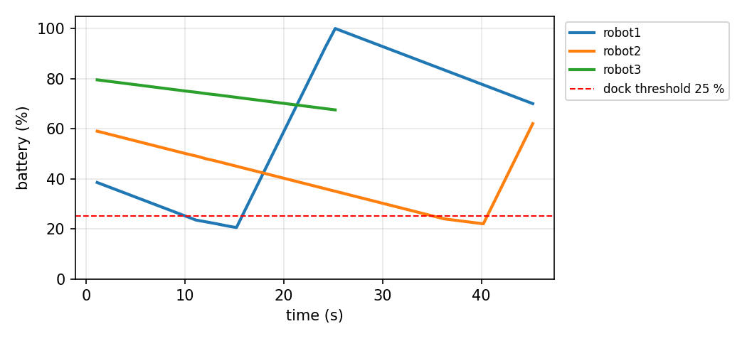
Figure 5.1: Battery of each robot over the scenario: robot1 and robot2 are docked automatically below 25 %; robot3’s data stops when it crashes at 25 s.
The two OFFLINE lines at 0.0 s are retained status messages left by an earlier run — the supervisor learns the last known state immediately, then sees the robots come ONLINE. In a separate test, a robot whose process was frozen was flagged by the 3 s watchdog at once, while the broker’s last will arrived only about 9–10 s later (keep-alive 5 s) — this is why the supervisor has its own heartbeat rule.

5.4 Test Cases, Limitations and Extensions
Test | Action | Expected result
TC1 | Run the scenario above | Dock commands near 11 s (robot1) and 36 s (robot2); robot3 OFFLINE at about 26 s
TC2 | Change --dock-below to 40 | robot1 is docked almost immediately
TC3 | Freeze a robot: kill -STOP <pid> | "no telemetry for 3 s" warning, OFFLINE later from the broker
TC4 | Stop the supervisor while robots run | Robots continue patrolling; no new commands (robots stay safe without the cloud)
TC5 | Restart the supervisor | Retained status gives the current online/offline state at once

Limitations: state is kept in memory (lost on restart); no authentication or TLS; one charger is assumed per robot; rules are fixed in code. Extensions: store telemetry in a time-series database; add TLS and a password per robot in mosquitto.conf; let the Lab 3 REST service show supervisor events; assign shared chargers so two robots never dock at the same one; or connect a ROS 2 robot through ros2_mqtt_bridge.py.

6. Troubleshooting and Common Mistakes
Problem | Likely cause | Fix
Connection refused on port 1883 | Broker not running, or only listening on localhost | Start mosquitto; for other PCs add a listener in mosquitto.conf
Connected but no messages | Topic spelling or wildcard wrong | mosquitto_sub -v -t '#' to see all traffic
Old values appear at start | Retained messages | Expected; clear with mosquitto_pub -r -n -t <topic>
Two clients keep disconnecting | Same client ID used twice | Give every client a unique client_id
Commands executed twice | QoS 1 can deliver duplicates | Make commands idempotent or add a command ID
Offline detected too late | Long keep-alive | Shorter keep-alive plus an application heartbeat
Works locally, fails in the cloud | Firewall/security group blocks the port | Open only the needed port; prefer TLS on 8883
High monthly bill | Too much data or idle servers | Lower telemetry rate, summarise data, stop unused servers
paho-mqtt callback errors | Old tutorial for paho-mqtt 1.x | Use CallbackAPIVersion.VERSION2 and v2 callback signatures

7. Assessment and Revision

7.1 Formula Sheet
Quantity | Formula
Cloud response time | T = T_capture + D/B_up + RTT + T_compute + T_act
Upload time | t = D (bits) ÷ B (bit/s); 1 kB = 8,000 bits
Minimum fibre RTT | RTT ≥ 2 × distance ÷ 200,000 km/s
Break-even uplink | B = D ÷ (T_local − RTT − T_cloud)
Telemetry volume | size × rate × robots × seconds
MQTT offline detection | ≈ 1.5 × keep-alive (plus broker check interval)

7.2 Short Conceptual Questions
- Give three benefits and three challenges of cloud robotics.
- Which robot functions must never depend on the cloud, and why?
- Explain the difference between IaaS, PaaS and SaaS with a robot example of each.
- Why are containers useful for deploying robot software and cloud services?
- What are MQTT retained messages and last-will messages used for in a fleet?
- Why should robots open connections to the cloud rather than accept incoming connections?
- Describe a safe over-the-air update process.
- Why is ROS 2 DDS not normally used directly across the internet, and what alternatives exist?
Answer key (brief): 1 — computing, sharing, fleet management; latency, connectivity, security. 2 — safety, fast control and obstacle avoidance: delay and dropouts. 3 — rented VMs; managed app platform; finished fleet dashboard. 4 — same image everywhere, fast start, easy updates. 5 — current status for new subscribers; offline detection. 6 — robots sit behind routers/firewalls; fewer open ports to attack. 7 — build, test, sign, canary, waves, rollback. 8 — multicast discovery and many ports; use MQTT bridges, rosbridge, Zenoh or a VPN.

7.3 Numerical Problems with Worked Solutions
Problem 1. Upload time of a 500 kB image over 20 Mbit/s? Solution: 500 × 8,000 = 4,000,000 bits ÷ 20,000,000 bit/s = 0.2 s.
Problem 2. Minimum RTT to a data centre 3,000 km away? Solution: 2 × 3,000 ÷ 200,000 = 30 ms.
Problem 3. Local processing 300 ms; cloud 20 ms; RTT 60 ms; 100 kB image. Break-even uplink? Solution: 100 × 8 ÷ (300 − 60 − 20) = 800 ÷ 220 = 3.6 Mbit/s.
Problem 4. 200 robots send 500-byte messages at 2 Hz. Data per 30-day month? Solution: 500 × 2 × 200 × 86,400 × 30 = 518 GB.
Problem 5. A teleoperated robot drives at 0.8 m/s with a total delay of 0.5 s. How far does it travel before the operator’s stop command takes effect? Solution: 0.8 × 0.5 = 0.4 m — why speed must be limited during teleoperation.
Problem 6. Keep-alive 10 s. Earliest time for the broker to declare a frozen client offline? Solution: 1.5 × 10 = 15 s (in practice a little more).

7.4 Practical Checklist and Rubric
# | The learner can… | Done
1 | Publish and subscribe with topics, wildcards, QoS, retained and last-will messages (Lab 1) | ☐
2 | Measure latency and justify an offloading decision with numbers (Lab 2) | ☐
3 | Build, test and containerise a REST fleet service (Lab 3) | ☐
4 | Implement fleet rules and a heartbeat watchdog (mini-project) | ☐
5 | Explain the security measures needed before connecting a real robot | ☐

Criterion (4 marks each) | Excellent (4) | Good (3–2) | Needs work (1–0)
Concepts and placement | Clear, calculated decisions | Mostly correct | Safety functions in cloud
Infrastructure and MQTT | Correct use of all features | Minor gaps | Not working
Cloud service | API correct, validated, containerised | Works with issues | Not working
Fleet application | All rules and tests pass | Some tests fail | Not completed
Security and report | Threats and measures explained | Partly explained | Missing

Glossary
Term | Meaning in simple words
Availability zone | Separate data centre within a cloud region, for fault tolerance.
Bandwidth | Amount of data a link can carry per second (Mbit/s).
Broker | MQTT server that receives and distributes messages.
Canary release | Updating a small group first to catch problems early.
Cloud computing | Renting computing resources over the internet on demand.
Cloud robotics | Robots using remote computing, storage and services.
Container | Packaged application with its libraries that shares the host OS kernel.
Digital twin | Live virtual copy of a robot or site kept up to date with data.
Docker / Kubernetes | Tools to build and run containers / to manage many containers.
Edge computing | Computing close to the robot, e.g. a server on the same site.
Fleet management | Monitoring, tasking and maintaining many robots together.
Heartbeat | Regular message showing that a device is alive.
IaaS / PaaS / SaaS | Infrastructure / Platform / Software as a Service.
Keep-alive | MQTT timer used to detect lost connections.
Last will (LWT) | Message the broker publishes if a client disappears.
Latency | Delay between an action and its response.
MQTT | Light publish/subscribe messaging protocol for devices.
Offloading | Moving computation from the robot to the edge or cloud.
OTA update | Over-the-air software update through the network.
QoS (MQTT) | Delivery guarantee: 0 at most once, 1 at least once, 2 exactly once.
Region | Geographic area containing a provider’s data centres.
REST API | Web interface using HTTP methods such as GET and POST.
Retained message | Last message on a topic stored by the broker for new subscribers.
Rollback | Returning to the previous software version after a failed update.
RTT | Round-trip time: time for a message to go and return.
Telemetry | Status data sent regularly from robot to cloud.
Teleoperation | Controlling a robot remotely by a human.
TLS | Encryption protocol that secures network connections.
Topic | Named channel in MQTT, e.g. fleet/robot1/telemetry.
VPN | Encrypted private network across the internet.
Wildcard | Topic pattern: + one level, # all lower levels.
Zenoh | Protocol for robot-to-cloud data, usable as a ROS 2 middleware.

References
The papers introduce key ideas and landmark projects in cloud robotics; the standards and documentation are the authoritative sources for protocols, tools and security practice. Cloud services change often, so check current provider documentation before building a production system.
[1] Kehoe, B., Patil, S., Abbeel, P., & Goldberg, K. (2015). A survey of research on cloud robotics and automation. IEEE Transactions on Automation Science and Engineering, 12(2), 398–409.
[2] Waibel, M., Beetz, M., Civera, J., et al. (2011). RoboEarth: A World Wide Web for robots. IEEE Robotics & Automation Magazine, 18(2), 69–82.
[3] Hunziker, D., Gajamohan, M., Waibel, M., & D’Andrea, R. (2013). Rapyuta: The RoboEarth cloud engine. Proc. IEEE ICRA.
[4] Levine, S., Pastor, P., Krizhevsky, A., Ibarz, J., & Quillen, D. (2018). Learning hand-eye coordination for robotic grasping with deep learning and large-scale data collection. International Journal of Robotics Research, 37(4–5), 421–436.
[5] Mell, P., & Grance, T. (2011). The NIST Definition of Cloud Computing (NIST SP 800-145).
[6] OASIS. (2019). MQTT Version 5.0. OASIS Standard. (MQTT 3.1.1 is also published as ISO/IEC 20922.)
[7] Eclipse Mosquitto documentation. https://mosquitto.org/documentation/
[8] Eclipse Paho MQTT Python client (paho-mqtt) documentation. https://eclipse.dev/paho/
[9] Flask documentation. https://flask.palletsprojects.com/
[10] Docker documentation. https://docs.docker.com/
[11] ROS 2 documentation (Jazzy). https://docs.ros.org/en/jazzy/
[12] Eclipse Zenoh. https://zenoh.io/
[13] IEC 62443 series. Security for industrial automation and control systems.
[14] ISO/IEC 27001:2022. Information security management systems — Requirements.
[15] Government of India. (2023). Digital Personal Data Protection Act, 2023.

